

Semester Two

Examination 2024

Question/Answer booklet

ATAR CHEMISTRY
UNITS 3&4

Name: Anne Swerkey

Marking allocation: 26 – 31, 38d – 40
32 – 35, 36 – 38c

TIME ALLOWED FOR THIS PAPER

Reading time before commencing work: Ten minutes
Working time for the paper: Three hours

MATERIALS REQUIRED/RECOMMENDED FOR THIS PAPER

To be provided by the supervisor:
This Question/Answer Booklet
Multiple-choice Answer Sheet
Chemistry Data Book

To be provided by the candidate:
Standard items: pens, pencils, eraser or correction fluid, ruler, highlighter.

Special items: calculators satisfying the conditions set by the SCSA for this subject.

IMPORTANT NOTE TO CANDIDATES
No other items may be taken into the examination room. It is your responsibility to ensure that you do not have any unauthorised notes or other items of a non-personal nature in the examination room. If you have any unauthorised material with you, hand it to the supervisor before reading any further.

Structure of this paper

Section | Number of questions available | Number of questions to be answered | Suggested working time  (minutes) | Marks available | Percentage of exam
Section One  Multiple-choice | 25 | 25 | 50 | 25 | 25
Section Two  Short answer | 10 | 10 | 60 | 76 | 35
Section Three  Extended answer | 5 | 5 | 70 | 89 | 40
 |  |  |  | Total | 100

Section One: Multiple-choice 25% (25 marks)
B C C C D A C B A D B A D A B

1 | a □ b ■ c □ d □ |  | 6 | a ■ b □ c □ d □ |  | 11 | a □ b ■ c □ d □
2 | a □ b □ c ■ d □ |  | 7 | a □ b □ c ■ d □ |  | 12 | a ■ b □ c □ d □
3 | a □ b □ c ■ d □ |  | 8 | a □ b ■ c □ d □ |  | 13 | a □ b □ c □ d ■
4 | a □ b □ c ■ d □ |  | 9 | a ■ b □ c □ d □ |  | 14 | a ■ b □ c □ d □
5 | a □ b □ c □ d ■ |  | 10 | a □ b □ c □ d ■ |  | 15 | a □ b ■ c □ d □

16 | a □ b □ c □ d ■ |  | 21 | a □ b □ c □ d ■
17 | a □ b □ c □ d ■ |  | 22 | a □ b □ c ■ d □
18 | a □ b □ c ■ d □ |  | 23 | a □ b □ c □ d ■
19 | a ■ b □ c □ d □ |  | 24 | a □ b □ c ■ d □
20 | a □ b ■ c □ d □ |  | 25 | a □ b ■ c □ d □
D D C A B D C D C B B A D A B

Section One: Multiple-choice 25% (25 marks)

This section has 25 questions. Answer all questions on the separate Multiple-choice Answer Sheet provided. For each question, shade the box to indicate your answer. Use only a blue or black pen to shade the boxes. If you make a mistake, place a cross through that square then shade your new answer. Do not erase or use correction fluid/tape. Marks will not be deducted for incorrect answers. No marks will be given if more than one answer is completed for any question.

Suggested working time: 50 minutes.

Questions 1 and 2 refer to the following equilibrium.

The chemical equation below represents the decomposition of calcium hydrogencarbonate.

Ca(HCO₃)₂(s) ⇌ CaCO₃(s) + H₂O(g) + CO₂(g)

This equilibrium was established at 60 °C in a sealed gas jar.

1. Which of the following changes would not result in an increased mass of Ca(HCO₃)₂(s) being present in the system?

- The addition of Ca(HCO₃)₂(s) to the system.
- The addition of CaCO₃(s) to the system.
- The addition of H₂O(g) to the system.
- The addition of CO₂(g) to the system.

2. If the lid of the gas jar was removed, this would result in:

- a closed system, where the forward reaction rate was equal to the reverse reaction rate.
- an open system, where the forward reaction rate was equal to the reverse reaction rate.
- an open system, where the forward reaction rate was faster than the reverse reaction rate.
- an open system, where the forward reaction rate was slower than the reverse reaction rate.

3. Which of these species forms a conjugate acid that is a zwitterion?

(a)
(b)
(c)
(d)
4. What is the purpose of the electrolytic refining process in copper production?

- To extract copper from its ore.
- To reduce copper oxide to elemental copper.
- To purify copper from impurities.
- To oxidise copper for use in industry.

5. What is the empirical formula of butan-1-amine?

- C₂H₅N_{0.5}
- C₂H₆N
- C₄H₁₀N
- C₄H₁₁N

Questions 6 and 7 refer to the information in the table below.

Name | Formula | K_{a1} value (first ionisation) | Proticity
Nitrous acid | HNO₂ | 4.0 x 10⁻⁴ | monoprotic
Iodic acid | HIO₃ | 1.6 x 10⁻¹ | monoprotic
Phosphoric acid | H₃PO₄ | 4.0 x 10⁻⁴ | triprotic
Oxalic acid | H₂C₂O₄ | 5.9 x 10⁻³ | diprotic

Consider four separate 100 mL samples of these acids, each with a concentration of 0.5 mol L⁻¹.

6. Rank these solutions in order from highest to lowest pH.

- HNO₂(aq) > H₃PO₄(aq) > H₂C₂O₄(aq) > HIO₃(aq)
- HNO₂(aq) > HIO₃(aq) > H₂C₂O₄(aq) > H₃PO₄(aq)
- HNO₂ (aq) > H₃PO₄ (aq) > HIO₃ (aq) > H₂C₂O₄ (aq)
- HIO₃(aq) > HNO₂(aq) > H₃PO₄(aq) > H₂C₂O₄(aq)

A solution of 0.5 mol L⁻¹ NaOH(aq) was then used to neutralise the acid in each of these four samples.

7. The acid sample requiring the largest volume of NaOH(aq) for neutralisation would be:

- HNO₂(aq).
- HIO₃(aq).
- H₃PO₄(aq).
- H₂C₂O₄(aq).

8. Consider the diagram below, which illustrates some of the electrochemical processes involved in the corrosion of iron.

air
water
iron
Fe(OH)₂(s)
Fe(OH)₂(s)
A
B
C

Identify the correct labels for A, B and C.

A B C
- Fe²⁺(aq) OH⁻(aq) anode
- Fe²⁺(aq) electrons cathode
- OH⁻(aq) electrons anode
- OH⁻(aq) Fe²⁺(aq) cathode

9. Which of the following identifies an advantage and a disadvantage of implementing green chemistry principles?

 | Advantage | Disadvantage
(a) | Decreased dependence on fossil fuels. | Higher production costs.
(b) | Improved human health and safety. | Increased environmental pollution.
(c) | Much faster production times. | Improved sustainability.
(d) | Decreased atom economy. | Requires infrastructure changes.

Questions 10 and 11 refer to the information provided in the table below, regarding the Haber and Contact processes.

Process | Main equilibrium reaction | Temperature used (°C) | Pressure used (atm)
Haber | N₂(g) + 3 H₂(g) ⇌ 2 NH₃(g) + 92 kJ | 350-550 | 100-350
Contact | 2 SO₂(g) + O₂(g) ⇌ 2 SO₃(g) + 196 kJ | 400-500 | 1-2

10. The most likely reason for the lower pressure used in the Contact process is:

(a) a high pressure increases the rate of the Haber process but not the rate of the Contact process.
(b) a high pressure increases the yield of the Haber process but not the yield of the Contact process.
(c) the yield of the Contact process is not affected by changes in pressure conditions.
(d) the yield considerations of the Contact process have been outweighed by the cost and safety benefits.

11. Identify the common industry that depends heavily upon both the Haber and Contact processes.

(a) Automotive
(b) Fertiliser
(c) Pharmaceutical
(d) Telecommunications

12. The following information applies to a particular reversible reaction.

“When the equilibrium of this system is established at room temperature,
there are predominantly reactants present. As the temperature of the
system gradually increases, the reactant concentration decreases.”

Which of the following pieces of data are consistent with this information?

ΔH (kJ mol⁻¹) K_{c} at 25 °C
- +32.7 4.17 x 10⁻¹¹
- +28.1 2.88 x 10⁴
- -91.6 3.23 x 10⁻⁸
- -55.5 6.17 x 10³

Questions 13 and 14 refer to the following organic compounds.

Consider the properties of the five (5) organic compounds below;

A
B
C
D
E

13. Which of these compounds would have the highest boiling point?

- A
- C
- D
- E

14. Which two (2) compounds could form a polymer when reacted together?

- A and B
- A and D
- C and D
- C and E

Questions 15 and 16 refer to the titrations described below.

Two titrations, A and B, were performed using the same indicator, which had an end point of 8.1 – 9.6. The titration curve for each is given below.

Titration A Titration B
pH 7–

–
–
–
–
–
–

–
–
–
–
–
–

pH 7–

–
–
–
–
–
–

–
–
–
–
–
–

15. Which of the following statements regarding these titrations is correct?

- The base was placed in the burette in both Titration A and Titration B.
- The observed colour change would be the same for both Titration A and Titration B.
- The acid used in Titration A would have a larger K_{a} value than the acid used in Titration B.
- The acid used in Titration A would be more concentrated than the acid used in Titration B.

16. Using this indicator would introduce a source of:

- random error into Titration A.
- systematic error into Titration A.
- random error into Titration B.
- systematic error into Titration B.

17. A sample of the electrolyte was taken from a cell performing the electrolytic refining of copper. The cell had been operating for several hours. Which of the following cations is least likely to be present in the electrolyte sample?

- Cu²⁺(aq)
- Zn²⁺(aq)
- Fe²⁺(aq)
- Ag⁺(aq)

18. Water softeners function to remove ions such as Ca²⁺(aq) and Mg²⁺(aq) from water, replacing them with Na⁺(aq) ions.

This would result in:

- detergents acting more effectively in the water.
- the pH of the water decreasing.
- soaps acting more effectively in the water.
- an increased likelihood of scum forming.

19. Consider the chemical reaction that takes place when methanol is combusted in excess oxygen gas. During this process, the oxidation number of carbon:

- increases by 6.
- decreases by 2.
- increases by 4.
- decreases by 4.

20. The chemical equations below represent two of the carbon-related equilibria existing in the oceans.

Equilibrium 1 HCO₃⁻(aq) + H₂O(l) ⇌ CO₃²⁻(aq) + H₃O⁺(aq)

Equilibrium 2 Ca²⁺(aq) + CO₃²⁻(aq) ⇌ CaCO₃(s)

Ocean acidification leads to an increased concentration of H₃O⁺(aq).

Which of the following correctly identifies the effect of this concentration change on the forward reaction rates of each of these equilibria?

 | Effect on rate of forward reaction  of Equilibrium 1 | Effect on rate of forward reaction  of Equilibrium 2
(a) | increased | increased
(b) | increased | decreased
(c) | decreased | increased
(d) | decreased | decreased

21. Consider the galvanic cell below, which has been constructed under standard conditions.

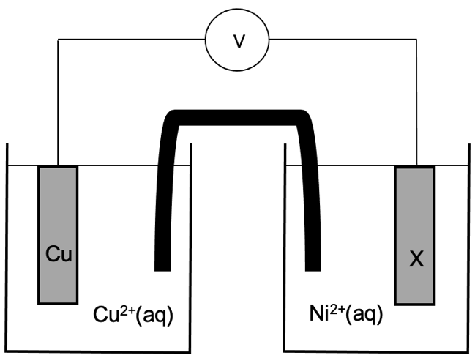

Which of the following metals, when used as electrode X, would result in the highest voltage being produced?

- Ag(s)
- Sn(s)
- Cd(s)
- Zn(s)
22. Identify the diagram which best illustrates the bond (shown as ) involved in forming a β-pleated sheet between asparagine and serine residues.
(a)
(b)
(c)
(d)

23. A sacrificial anode acts to:

- minimise the chance of oxygen and water coming into contact with the iron.
- decrease the oxidation potential of iron, so that it is more resistant to corrosion.
- ensure that water and oxygen are oxidised preferentially to the iron.
- transfer electrons to the iron, allowing it to resist oxidation.

Questions 24 and 25 refer to the information below.

High-density polyethene (HDPE) and low-density polyethene (LDPE) are both polymers produced from the monomer ethene. However, the different reaction conditions used to produce them, result in either long straight polymer chains, in the case of HDPE, or chains with many side branches, as seen in LDPE.

HDPE | LDPE

24. When compared to LDPE, HDPE has a:

(a) lower melting point.
(b) greater transparency.
(c) higher mass per unit volume.
(d) lower rigidity.

25. Which of the following identifies a common use of HDPE and LDPE?

HDPE LDPE
(a) plastic bottles plastic chairs
(b) takeaway containers plastic bags
(c) packaging film seatbelts
(d) medical tubing playground equipment

End of Section One

Section Two: Short answer 35% (76 marks)

Question 26 (6 marks)

(a) Justify whether this equation represents the chemical reaction taking place during the ‘recharge’ or ‘discharge’ cycle of the lead-acid accumulator. Use standard reduction potential data to support your answer. (4 marks)

Description | Marks
Relevant SRP table data:  PbSO₄(s) + 2 e⁻ → Pb(s) + SO₄²⁻(aq) E⁰(red) = –0.36 V  PbSO₄(s) + 2H₂O(l)→PbO₂(s) + SO₄²⁻(aq) + 4H⁺(aq) + 2e⁻ E⁰(ox) = –1.69 V  or  PbO₂(s) + SO₄²⁻(aq) + 4H⁺(aq) + 2e⁻→PbSO₄(s) + 2H₂O(l) E⁰(red) = +1.69 V  Pb(s) + SO₄²⁻(aq) → PbSO₄(s) + 2 e⁻ E⁰(ox) = +0.36 V | 1
EMF = –0.36 – 1.69 = –2.05 V | 1
Recognition that a negative EMF corresponds to a non-spontaneous reaction / to a requirement for electrical energy input. | 1
Recognition that the reaction therefore represents the recharge cycle. | 1
Total | 4

(b) State one use of the lead-acid accumulator. (1 mark)

Description | Marks
Any one (1) of the following uses;  - car / vehicle battery  - electric scooters / wheelchairs / bicycles  - boat battery  - electric forklifts  - golf carts  - submarines  - back up power supplies  - lighting | 1
Total | 1

(c) Identify one safety concern associated with the lead-acid accumulator. (1 mark)

Description | Marks
Any one (1) of the following safety concerns;  - lead is poisonous / a neurotoxin  - sulfuric acid electrolyte is corrosive / may cause skin burns  - environmental concerns of disposal | 1
Total | 1

Question 27 (8 marks)

(a) A solution of potassium hydroxide was added dropwise to a beaker containing aqueous propanoic acid. Use structural representations for any organic species present. (2 marks)

Description | Marks
CH₃CH₂COOH(aq) + OH⁻(aq) → H₂O(l) + CH₃CH₂COO⁻(aq)
Correct species | 1
Correct balancing | 1
Total | 2
Note: state symbols are not required for full marks.

(b) Chlorine gas is bubbled through a solution of 0.1 mol L⁻¹ sodium iodide. (2 marks)

Description | Marks
Cl₂(g) + 2 I⁻(aq) → I₂(aq) + 2 Cl⁻(aq)
Correct species | 1
Correct balancing | 1
Total | 2
Note: state symbols are not required for full marks.

(c) A piece of cobalt metal is placed into a beaker containing excess 0.5 mol L⁻¹ sulfuric acid solution. (2 marks)

Description | Marks
Silver solid is added to/dissolves in colourless solution | 1
Colourless, (odourless) effervescence/bubbling as pink solution forms | 1
Total | 2

(d) A 1 mol L⁻¹ nickel chloride solution is poured over some small pieces of lead metal. (2 marks)

Description | Marks
Green solution added to grey solid | 1
No observable change | 1
Total | 2

Question 28 (7 marks)

(a) Complete the table above by writing the IUPAC name for each compound. (3 marks)

Description |  | Marks
A | methyl ethanoate | 1
B | propanamide | 1
C | 4,4-dibromobutan-2-one | 1
Total |  | 3

(b) State which compound is likely to have the highest solubility in water. Explain your answer in terms of intermolecular forces. (4 marks)

Description | Marks
Compound B / propanamide | 1
Recognition that compound A, B and C are all able to form hydrogen bonding, dipole-dipole forces and dispersion forces with water. | 1
Recognition that Compound B has the greatest number of sites to form hydrogen bonding with water. | 1
Recognition that this would allow a greater number of attractions, between molecules of compound B and between molecules of water, to be disrupted (resulting in the highest solubility).  OR  Recognition that the solute-solvent forces between water and propanamide will be stronger than the solute-solvent forces between water and the other two (resulting in the highest solubility). | 1
Total | 4

Question 29 (3 marks)

A sample of pure water was stored in the fridge at a temperature of 4.0 °C. The pH of this water was measured using a digital pH meter and found to be 7.39.

Calculate the value of K_{w} at 4.0 °C.

Description | Marks
[H⁺] = 10^{-7.39}  = 4.0738 x 10⁻⁸ mol L⁻¹ | 1
= [OH⁻] | 1
K_{w} = [H⁺] [OH⁻]  = (4.0738 x 10⁻⁸) x (4.0738 x 10⁻⁸)  = 1.66 x 10⁻¹⁵ | 1
Total | 3

Question 30 (6 marks)

(a) Identify whether this species represents a soap or detergent. (1 mark)

Description | Marks
Soap | 1
Total | 1

(b) Add to the diagram above, to show how this species interacts with both fat and water.
Your diagram should include;
- one fat molecule
- one water molecule
- labels showing the predominant type of forces acting between this species and the fat and water molecules. (5 marks)

Description | Marks
Fat molecule drawn correctly (may be structural or condensed) | 1
Fat molecule contains at least 10 carbons on each ‘arm’ | 1
Dispersion forces between fat and non-polar tail labelled | 1
Ion-dipole forces between water and polar head labelled | 1
Water molecule oriented correctly towards carboxylate ion | 1
Total | 5

Question 31 (11 marks)

(a) Write the equilibrium constant expression for this reaction. (2 marks)

Description | Marks
[Fe²⁺] [H₂S]  [H⁺]²  K = | 2
Total | 2
Note: award 1 mark for minor error, such as missing ion charge

(b) Complete the following table by stating how each of the imposed changes would affect;
(i) the rate of the forward reaction, and
(ii) the position of equilibrium. (4 marks)
Note: consider the effect of each of these changes in isolation.

Description | Marks
Rate of forward reaction Position of equilibrium  The partial pressure of H₂S(g) was increased. increased shift right  A sample of distilled water was added. decreased shift right  Award 1 mark per correct cell. | 4
Total | 4

(c) On the grid below, continue the curves to illustrate the concentration changes that would occur from Time T1 until after Time E2. (5 marks)

Description | Marks
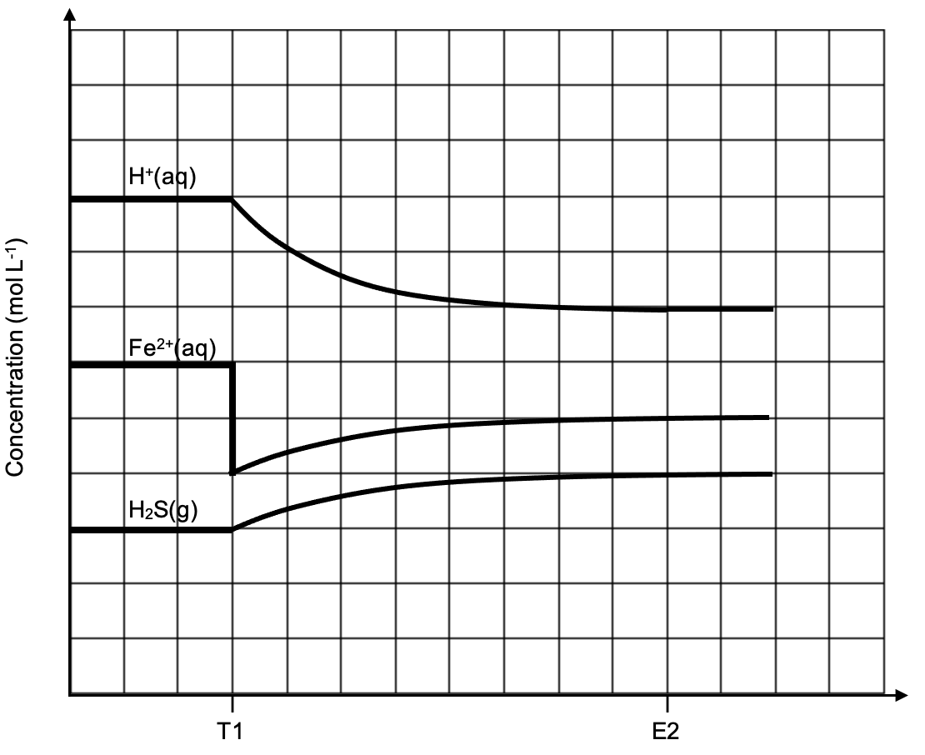

At T1; initial decrease only for [Fe²⁺] | 1
Between T1 and E2; [H⁺] decreasing, [Fe²⁺] / [H₂S] increasing | 1
Between T1 and E2; gradient of [H⁺] twice that of [Fe²⁺] / [H₂S] | 1
At E2; all lines horizontal | 1
At E2; [Fe²⁺] concentration below original | 1
Total | 5

Question 32 (11 marks)

(a) Use this information to justify the statement below. Your answer should include relevant definitions and chemical equations. (7 marks)

“A conjugate acid is not always acidic.”

Description | Marks
Recognition that a conjugate acid is a species with one additional proton/H⁺ compared to another. | 1
Recognition that HCO₃⁻ is the conjugate acid of CO₃²⁻. | 1
Recognition that an acidic solution means [H₃O⁺] > [OH⁻] / an excess of H₃O⁺. | 1
Recognition that both HCO₃⁻ and CO₃²⁻ are basic because they hydrolyse with water to produce an excess of OH⁻ / [OH⁻] > [H₃O⁺]. | 1
HCO₃⁻(aq) + H₂O(l) ⇌ H₂CO₃(aq) + OH⁻(aq) | 1
CO₃²⁻(aq) + H₂O(l) ⇌ HCO₃⁻(aq) + OH⁻(aq) | 1
Correct use of equilibrium arrows in both equations | 1
Total | 7
Note: state symbols are not required for full marks.

(b) Explain how the buffering capacity of Buffer A and Buffer B would differ. (4 marks)

Description | Marks
Recognition that buffer A has a higher concentration of the acidic buffer species / HCO₃⁻. | 1
Recognition that buffer A would therefore have a greater buffering capacity upon addition of OH⁻(aq). | 1
Recognition that buffer B has a higher concentration of the basic buffer species / CO₃²⁻. | 1
Recognition that buffer B would therefore have a greater buffering capacity upon addition of H₃O⁺(aq). | 1
Total | 4

Question 33 (7 marks)

(a) Complete this reaction sequence, by drawing structural formulae for the organic compounds in the boxes labelled A, B, C and D. (4 marks)

Description |  | Marks
A |  | 1
B |  | 1
C |  | 1
D | 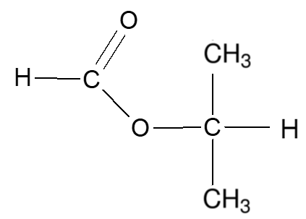 | 1
Total |  | 4

(b) Name the type of reaction occurring at; (3 marks)

Description |  | Marks
W | Addition / hydration | 1
X & Y | Oxidation / redox | 1
Z | Esterification | 1
Total |  | 3

Question 34 (9 marks)

(a) Write balanced oxidation and reduction half-equations and an overall redox equation for this reaction. (5 marks)

Description | Marks
Oxidation half-equation:  Cr(s) → Cr³⁺(aq) + 3 e⁻ | 1
Reduction half-equation:
2 HOBr(aq) + 2 H⁺(aq) + 2 e⁻ → Br₂(aq) + 2 H₂O(l)
Correct species | 1
Correct balancing | 1
Overall redox equation:
2 Cr(s) + 6 HOBr(aq) + 6 H⁺(aq) → 2 Cr³⁺(aq) + 3 Br₂(aq) + 6 H₂O(l)
Correct species | 1
Correct balancing | 1
Total | 5
Note: state symbols are not required for full marks.
final equation must have merit to gain follow through marks

(b) In the boxes on the diagram below, use chemical formulae to label the substances that would be required to accomplish this cell design. Include state symbols. (4 marks)

Description | Marks
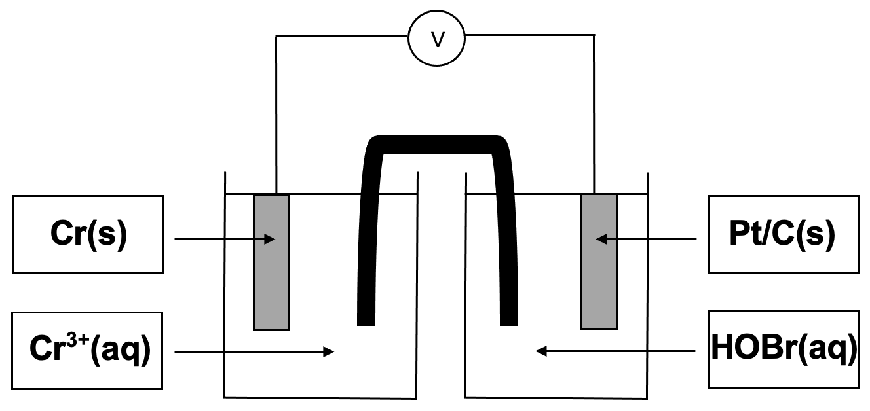  Award 1 mark per correct box. | 4
Total | 4
Note: half-cells may also be labelled in reverse, i.e. Cr(s) / Cr³⁺(aq) on the right side, Pt(s) / HOBr(aq) on the left side.

Question 35 (8 marks)

(a) Define a protein and describe its primary structure. (2 marks)

Description | Marks
Recognition that proteins are large polymers/long chain polypetides made from amino acid monomers. | 1
Recognition that the primary structure is the sequence of amino acids. | 1
Total | 2

(b) Define a catalyst. (2 marks)

Description | Marks
Recognition that a catalyst increases the reaction rate. | 1
Recognition that a catalyst is not used up in the reaction.  or  Recognition that a catalyst provides an alternate reaction pathway with a lower activation energy. | 1
Total | 2

(c) Which energy profile, A or B, represents this method? (1 mark)

Description | Marks
A | 1
Total | 1

(d) Identify a suitable catalyst used in this method. (1 mark)

Description | Marks
Zymase / yeast | 1
Total | 1

(e) Identify two (2) advantages of utilising the fermentation method compared to the hydration method for producing ethanol. (2 marks)

Description | Marks
Any two (2) of many possible advantages, including;  - process performed at lower temperature  - process performed at lower pressure  - no corrosive acid catalyst used  - milder pH conditions used  - uses renewable resources  - process is more energy efficient  - saves money (using lower temperature and pressure)  - safer conditions for workers | 2
Total | 2

Section Three: Extended answer 40% (89 marks)

Question 36 (15 marks)

(a) Explain each of the following observations, with reference to collision theory and/or the concentration of relevant species where required.

(i) Initially, the colour of the gas mixture became a much darker brown. (2 marks)

Description | Marks
Recognition that a decrease in volume increases the concentration of all gaseous species / reduces the space between all gas particles. | 1
Recognition that the darker brown colour is a result of increased NO₂(g) concentration. | 1
Total | 2

(ii) Subsequently, the brown colour of the gas mixture began to lighten. (5 marks)

Description | Marks
Recognition that there is an increased frequency of collisions between all species. | 1
Recognition that the forward and reverse reaction rates are both increased. | 1
Recognition that the forward reaction rate is increased to a greater extent than the reverse reaction rate due to 2:1 ration/more reactant particles than products. | 1
Recognition that the position of equilibrium shifts to the right. | 1
Recognition that the lightening of the brown colour is due to the decrease in concentration of NO₂(g). | 1
Total | 5

(iii) Finally, the shade of brown of the gas mixture remained the same. However, it was a darker brown than the original equilibrium mixture. (3 marks)

Description | Marks
Recognition that the rate of forward and reverse reactions are equal and ongoing. | 1
Recognition that the brown colour does not change because the concentration of NO₂(g) is constant. | 1
Recognition that the colour remains darker than the original mixture because (the volume of the syringe is still less than originally, and thus) the concentration of NO₂(g) is still higher than in the original mixture. | 1
Total | 3

(b) Predict the effect this temperature increase would have on the value of K_{c}. Using Le Chatelier’s principle, justify your answer. (5 marks)

Description | Marks
Recognition that LCP predicts an increase in temperature will be partially opposed by favouring the direction that consumes heat. | 1
Recognition that the reverse, endothermic direction will be favoured / equilibrium shifts left to favour endothermic reaction. | 1
Recognition that this will result in an increased concentration of reactants / a decreased concentration of products. | 1
Recognition that K_{c} is equivalent to [products] / [reactants]. | 1
Recognition that K_{c} will decrease. | 1
Total | 5

Question 37 (19 marks)

(a) In addition to the three (3) fatty acids, name the other molecule required to form this triglyceride. (1 mark)

Description | Marks
Glycerol / propane-1,2,3-triol | 1
Total | 1

(b) Oleic acid and linoleic acid are classified as unsaturated fatty acids. What feature of their structure makes them unsaturated? (1 mark)

Description | Marks
Recognition that one or more double C=C bonds must be present. | 1
Total | 1

(c) State the most common catalyst that is used for this reaction. (1 mark)

Description | Marks
NaOH / KOH | 1
Total | 1

(d) Draw the structure of the most abundant biodiesel molecule that would be produced by this reaction. (2 marks)

Description | Marks
Ethyl group correctly shown | 1
Oleate chain correctly shown (may be structural or condensed) | 1
Total | 2

(e) Which of the four amino acids mentioned, would not be able to participate in forming ionic bonds as part of the tertiary structure of arachin? (1 mark)

Description | Marks
Leucine | 1
Total | 1

(f) Draw a structural diagram showing the final three (3) amino acid residues in the arachin polypeptide. (4 marks)

Description | Marks
Correct amino acids used (i.e. correct side chains shown) | 1
Amino acids in correct order | 1
Both peptide links correctly shown | 1
N terminus shown non-terminating, C terminus shown terminating | 1
Total | 4

(g) Determine the empirical formula of this amino acid, and thereby identify it. (9 marks)

Description | Marks
Calculating moles and percentage/mass of C | 2
Calculating moles and percentage/mass of H | 2
Calculating percentage/mass of O | 1
Determining moles of each element | 1
Determining simplest ratio by dividing all by smallest moles | 1
Writing empirical formula as C₅H₉NO₄ | 1
Stating amino acid is Glu | 1
Total | 9
n(CO₂) = 1.568/44.01
= 3.5628 x 10⁻² mol = n(C)

%C = (((3.5628 x 10⁻²) x 12.01)/1.048) x 100
= 40.8297 %

n(H₂O) = 0.5776/18.016
= 3.206 x 10⁻² mol

n(H) = 2 x n(H₂O)
= 2 x (3.206 x 10⁻²)
= 6.412 x 10⁻² mol

%H = (((6.412 x 10⁻²) x 1.008)/1.048) x 100
= 6.1673 %
%O = 100 – (40.8297 + 6.1673 + 9.52)
= 43.4829 %

 | C | H | N | O
mass in 100g (g) | 40.8297 | 6.1673 | 9.52 | 43.4829
moles (mol) | 40.8297/ 12.01  = 3.3996 | 6.1673/1.008  = 6.1184 | 9.52/14.01  = 0.6795 | 43.4829/16.00  = 2.7177
ratio  = | 3.3996/ 0.6795 | 6.1184/ 0.6795 | 0.6795/ 0.6795 | 2.7177/ 0.6795
 | 5.00 | 9.00 | 1.00 | 4.00
round | 5 | 9 | 1 | 4

Empirical formula is C₅H₉NO₄. The identity of the amino acid is Glu.

Question 38 (18 marks)

(a) On the diagram above, circle and label two (2) different functional groups present in malic acid. (2 marks)

Description | Marks
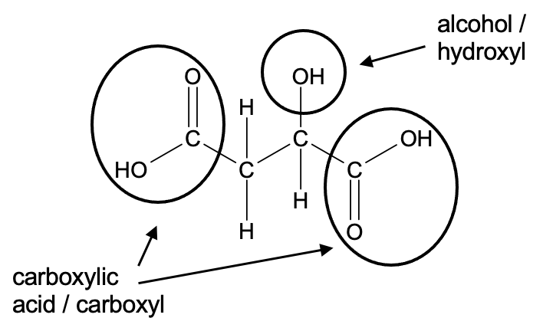

Alcohol / hydroxyl group circled and labelled correctly | 1
Either carboxylic acid / carboxyl group circled and labelled correctly | 1
Total | 2

(b) Explain why sodium hydroxide is not suitable to use as a primary standard. (2 marks)

Description | Marks
Recognition that NaOH(s) is deliquescent / hygroscopic / reacts with water in the air / reacts with CO₂(g) in the air. | 1
Recognition that a weighed mass of NaOH(s) cannot be accurately measured. | 1
Total | 2

(c) Determine the size of pipette that was used to prepare the HCl(aq) aliquots. Support your answer with relevant calculations. (4 marks)

Description | Marks
n(NaOH) = 0.08993 x 0.01812  = 0.0016295 mol | 1
= n(HCl) | 1
V(HCl) = 0.0016295 / 0.1086  = 0.01500 L | 1
A 15.00 mL pipette was used. | 1
Total | 4

(d) Calculate the average titre. (2 marks)

Description | Marks
Uses only Trials 1, 2 and 4 | 1
V(av. titre) = (6.25 + 6.21 + 6.14) / 3  = 6.20 mL | 1
Note: do not accept 6.2 mL Total | 2

(e) Give one systematic error and one random error that occur in this titration. (2 marks)

Description | Marks
Systematic (any one)  - inherent/calibration error in the pipette  - inherent/calibration error in the burette  - inherent/calibration error in the volumetric flask | 1
Random (any one)  - reading the meniscus in the pipette/burette/volumetric flask  - judging consistent end point with indicator | 1
Total | 2

(f) Calculate the concentration of malic acid in the apple juice, in grams per litre. (6 marks)

Description | Marks
n(NaOH) = 0.08993 x 0.00620  = 0.0005576 mol | 1
n(C₄H₆O₅ in 20 mL) = ½ x n(NaOH)  = 0.0002788 mol | 1
n(C₄H₆O₅ in 100 mL) = 0.0002788 x (100 / 20)  = 0.001394 mol | 1
= n(C₄H₆O₅ in 75 mL apple juice) | 1
m(C₄H₆O₅) = 0.001394 x 134.088  = 0.1869 g | 1
c(C₄H₆O₅) = 0.1869 / 0.075  = 2.49 g L⁻¹ | 1
Total | 6

Question 39 (15 marks)

(a) Write a chemical equation representing the hydrolysis of caprolactam. Use structural formulae for all organic compounds. (2 marks)

Description | Marks
Correct reactants | 1
Correct products | 1
Total | 2

(b) Explain why 6-aminohexanoic acid is not classified as an ‘α-amino acid’. (1 mark)

Description | Marks
The amine and the carboxyl group are not attached to the same first carbon / the alpha carbon. | 1
Total | 1

(c) Define an isomer. (1 mark)

Description | Marks
Compounds with the same molecular formula but different structures. | 1
Total | 1

(d) Name, or give the three-letter symbols for, the two (2) α-amino acids that are isomers of 6-aminohexanoic acid. (2 marks)

Description | Marks
Isoleucine / Ile | 1
Leucine / Leu | 1
Total | 2

(e) Draw two (2) repeating units of the polymer nylon-6, which is formed by polymerisation of 6-aminohexanoic acid. (3 marks)

Description | Marks
Two repeating units shown | 1
Amide link correctly shown | 1
Non-terminating ends shown | 1
Note: Can draw the repeating unit the opposite way around Total | 3

(f) What type of condensation polymer is nylon-6? (1 mark)

Description | Marks
Polyamide | 1
Total | 1

(g) Which of these products would nylon-6 be most suited for? Circle your choice below, and justify your answer in terms of the main property of nylon-6 which results in the desired characteristics. (2 marks)

Description | Marks
Carpet fibres (circled) | 1
Recognition that hydrogen bonds are present in polyamides / nylons (which would contain the desired characteristics for carpet fibre). | 1
Total | 2

(h) Define ‘crosslinking’ and explain how crosslinks are able to alter the properties of a polymer. (3 marks)

Description | Marks
Recognition that crosslinking involves the formation of covalent bonds between different polymer chains. | 1
Any two (2) of the following;  Recognition that crosslinks  - create a polymer network.  - increase the molar mass of the polymer molecules.  - increase the melting point of the polymer.  - reduces the mobility of the polymer chains.  - increase the rigidity of the polymer. | 2
Total | 3

Question 40 (22 marks)

(a) Justify the temperature and pressure conditions used in the steam-methane reforming reaction. (6 marks)

Description | Marks
Recognition that high temperature will produce a fast rate of reaction. | 1
Recognition that high temperature will produce a high yield of reaction, due to the endothermic / forward reaction being favoured. | 1
Recognition that 1000 °C is used due to cost limitations. | 1
Recognition that the rate of reaction is increased by a high pressure.  or  Recognition that the rate of reaction is decreased by a low pressure. | 1
Recognition that the yield is decreased by a high pressure since the reverse reaction (which produces a smaller number of gaseous species) would be favoured.  or  Recognition that the yield is increased by a low pressure since the forward reaction (which produces a greater number of gaseous species) would be favoured. | 1
Recognition that 1500 kPa constitutes use of a compromise pressure to ensure acceptable yield at a reasonable rate. | 1
Total | 6

(b) Calculate the total mass of H₂(g) that was produced. State your answer to the appropriate number of significant figures. (7 marks)

Description | Marks
m(CH₄) = 612 x 10³ g | 1
n(CH₄) = 612000 / 16.042  = 38149.9 mol | 1
n(H₂ from Step 1) = 3 x 38149.9 x (92.7 / 100)  = 106094.8 mol | 1
n(H₂ from Step 2) = 38149.9 x (92.7 / 100) x (88.1 / 100)  = 31156.5 mol | 1
n(H₂ total) = 106094.8 + 31156.5  = 137251.2 mol | 1
m(H₂) = 137251.2 x 2.016  = 276699 g  = 2.77 x 10⁵ g or 277 kg | 1
Answer stated to 3 significant figures. | 1
Total | 7

(c) Determine which of the fuel cell reactants would run out first. Use relevant calculations to support your answer. (4 marks)

Description | Marks
V(O₂) = (21 / 100) x 1.84 x 10⁶  = 386400 L | 1
n(O₂) = ( 448 x 386400 ) / ( 8.314 x 305.65 )  = 68121 mol | 1
Mole to mole comparison  n(O₂) = 68121 / 1  = 68121 mol  n(H₂) = 137251.2 / 2  = 68626 mol | 1
Therefore O₂(g) is the limiting reagent since there is less present on a mole to mole basis. | 1
Total | 4
Note: accept other chemically acceptable methods of determining limiting reagent
award follow through marks from part (b)

(d) Explain why a fuel cell is classified as a galvanic cell, but is neither a primary nor secondary cell. (2 marks)

Description | Marks
Recognition that a fuel cell is galvanic because it produces electricity from a spontaneous redox reaction. | 1
Recognition that a fuel cell is not primary or secondary because reactants need to be continuously fed into the cell. | 1
Total | 2

(e) Identify whether H₂(g) enters the hydrogen fuel cell at the anode or the cathode. Justify your answer, with the use of oxidation numbers. (3 marks)

Description | Marks
Hydrogen enters at the anode. | 1
Recognition that oxidation always occurs at the anode of an electrochemical cell. | 1
Recognition that the oxidation number of H₂ increases from (0) to (+1) in H₂O, thus H₂ is oxidised. | 1
Total | 3

